​BMI CALCULATOR APP DEVELOPMENT
Author: G.Harsha Priya
Final year IT
St.Joseph's Institute Of Technology

ACKNOWLEDGEMENTS 1

CONTENTS 2

INTRODUCTION 3

OVERVIEW 3
BACKGROUND AND MOTIVATION 3
METHODOLOGY 5

TOOL DESCRIPTION 6

USER INTERFACE 6
FEATURES 6
SPECIFICATION 9

MODULE DESCRIPTION...........................................................................................................................N

VISUALISATION.......................................................................................................................................N

IMPLEMENTATION...................................................................................................................................N

FUTURE WORK.......................................................................................................................................N

REFERENCES.........................................................................................................................................29

OVERVIEW

The application is developed in order to find out the BMI of a person. This application verifies that a person is fit or lean or obese. The BMI can be calculated by first calculating the height and weight of a person. If the BMI of a person is calculated at a range of 19 to 25,the person is normal. If the BMI is less than 19 he is lean and if the BMI is above 25 the person is obese. If the person is unfit that means if the person is lean or obese the application give suggestions for the person to become normal.

BACKGROUND AND MOTIVATION

The main goal of the application is to give knowledge among people how important is to being in normal weight. Keeping track of your BMI is an important pat of staying healthy. Nowadays many are died at the early age because of obesity. Therefore awareness should be created among everyone that being in normal weight is the essential in our living. People with less BMI are tend to caught by many viral diseases easily so being less weight is also danger. This application helps people to become physically fit by giving suggestions and active remainder for the people who registered into this.

OBJECTIVE
The final goal of the project was twofold.
- An Integrated Framework was required for interaction with the various tools (like Software/Hardware Estimation, Partitioning, Synthesis tools etc.) with the platform specification being done in the application itself.
- Based on the final platform configuration and bindings, an Analysis and Visualization framework was required for getting performance metrics of the system and for visualization of the analysis results and the target platform.
Along with above main goals , capability to design the target platform manually was also desired.

METHODOLOGY
To implement the above goals , the following methodology needs to be followed :
- Specifying the Application and various components of the Architecture.
- Specifying the bindings between the tasks and the resources either manually or by the design tools.
- Specifying the port interconnections between the resources.
- Analysis : Extracting the data required for analysis and the doing the analysis.
USER INTERFACE
The tool is very user friendly and intuitive and uses a GUI interface implemented in java (for android ) to communicate wih the user. Various features are self – explanatory.
Forms are easy to fill in and components can be added , removed and updated very easily through a single dialog box. The application includes tool-tip hints to give a brief description of the particular input field.
List boxes are used to display all the components at once so that user can see all the components of a particular type at once. One can just select the component and modify and remove the component.

FEATURES
- Intuitive interface
- Clean separation of various components to facilitate easy modification and revision.
3.All the configuration data is maintained in a separate file to facilitate easy modification specification will prove to be extremely useful. Also maintaining a separate file for the purpose helps in centralisation of the data for easy understanding of the source code and the implementation methodology.
4. Analysis Component is kept modular to facilitate multiple analysis models.

Analysis models may need upgradation from time to time depending upon the varying nature of the systems the tool may be used for. To facilitate easy upgradation of analysis model great care has been undertaken

  - All the data required for analysis is kept in a separate file.
  - The data is collected by a 'data collator' which collects data from the various data sources (application specification, target platform specification, SUIF annotations, user etc.). As the data is generated by the other tools and stored in the SUIF annotations, only this data collator needs to be changed without disturbing the rest of the analysis.
- Quick and easy saving and loading of System configuration.

Since the specification of the Application and the Target Platform can be very intricate, a option for saving the current configuration is a very much desired. All the configuration data (including the binding and the interconnection information) could be easily stored in different files. So one can work on multiple configurations simultaneously. In fact, it is made as convenient as saving, loading and editing a text file from a standard text-editor.

MODULES DESCRIPTION

1.SIGNUP
This is the first module of the application which gets the name, sex and age of a person.

2.BMI CALCULATOR
This module gets the height and weight of the user. Once the person verifies his given height and weight the application calculates the BMI of the person. It also tells the person is normal, lean or obese by the calculated BMI of that person and the suggestions are given for the people separately for lean and obesity respectively.

3.RESULT
The final result is stored in the database so that the person can then takes practice and check for the improvement in the coming years.

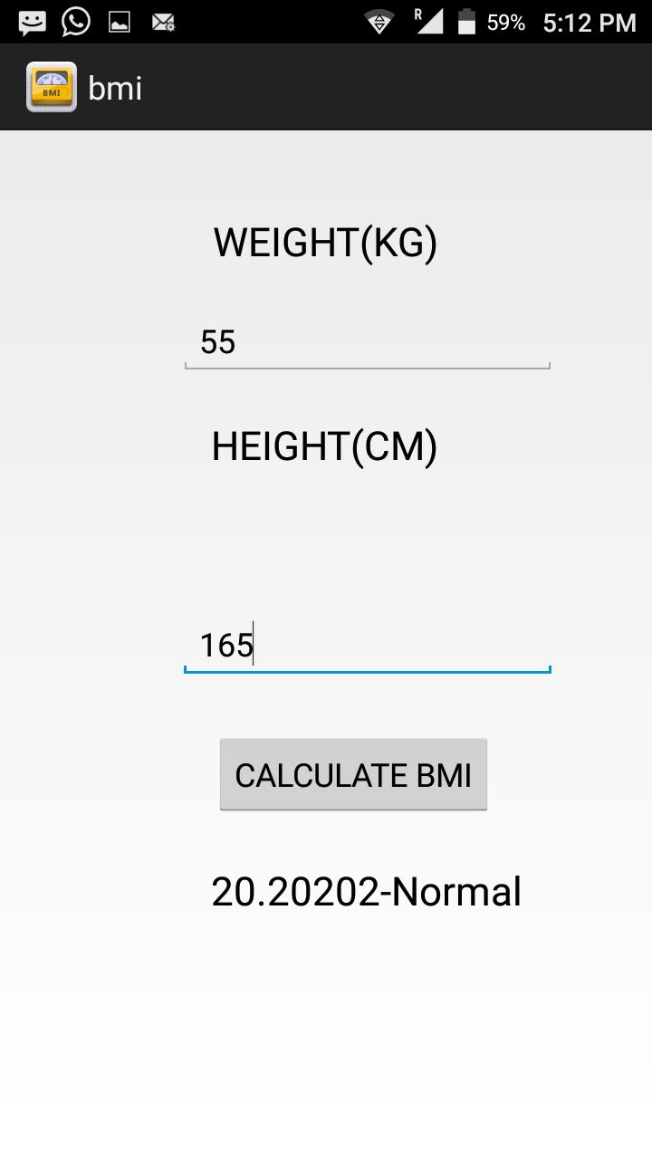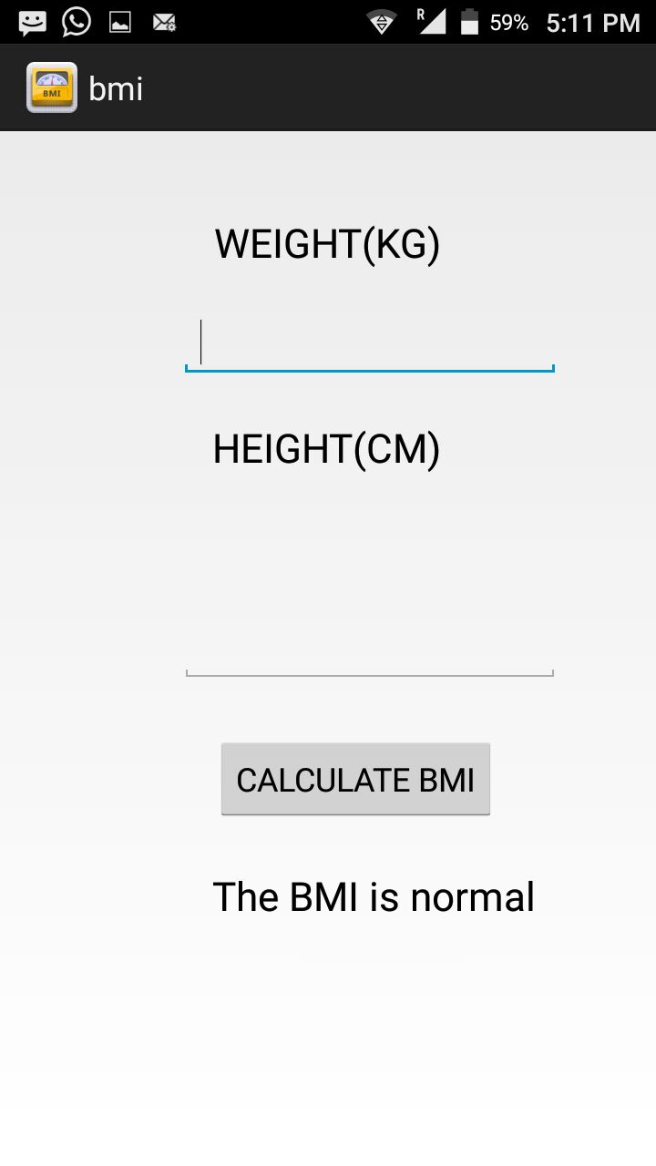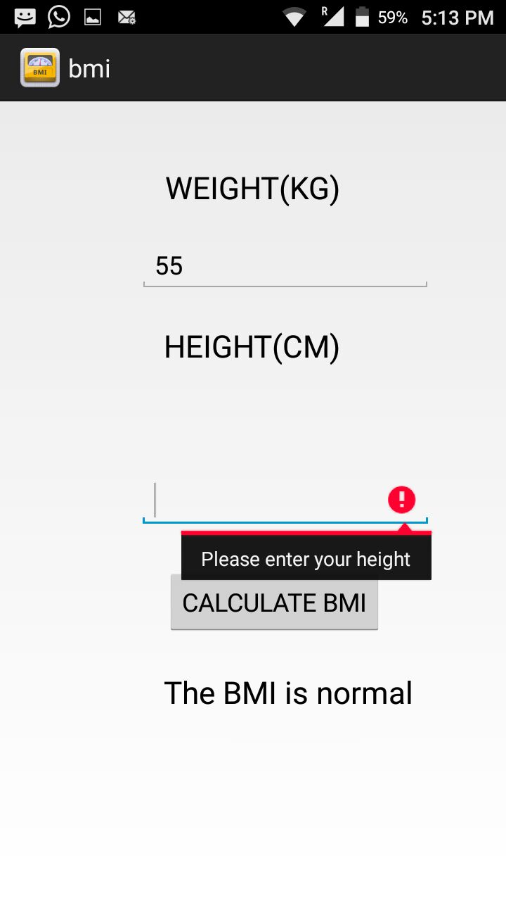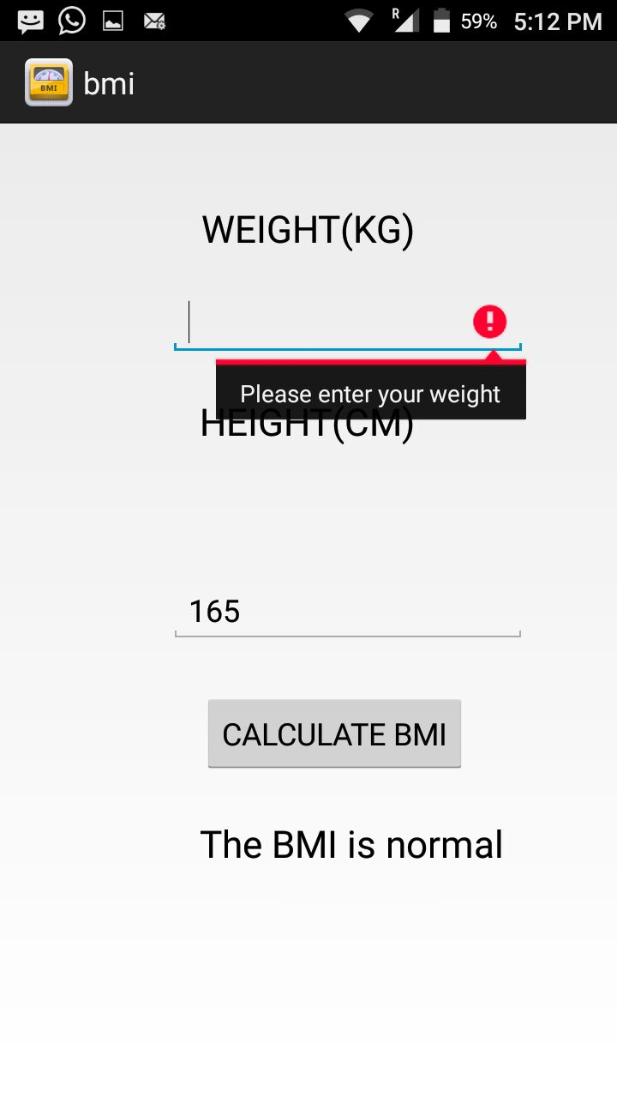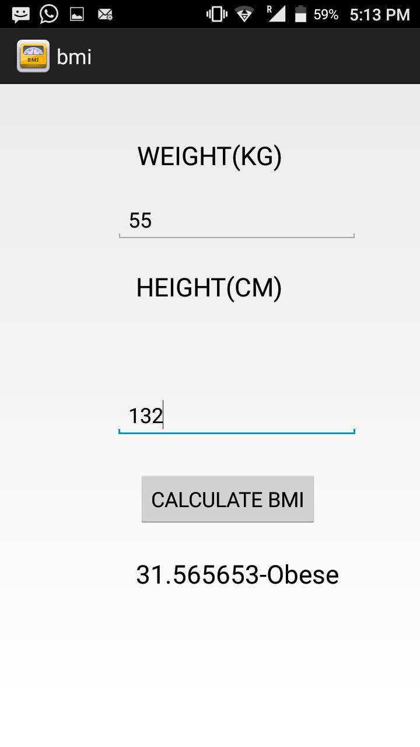

IMPLEMENTATION
activity_main.xml
<RelativeLayout xmlns:android="http://schemas.android.com/apk/res/android"
xmlns:tools="http://schemas.android.com/tools"
android:layout_width="match_parent"
android:layout_height="match_parent"
android:paddingBottom="@dimen/activity_vertical_margin"
android:paddingLeft="@dimen/activity_horizontal_margin"
android:paddingRight="@dimen/activity_horizontal_margin"
android:paddingTop="@dimen/activity_vertical_margin"
tools:context=".MainActivity"
tools:ignore="TextFields" >

<TextView
android:id="@+id/textView2"
android:layout_width="wrap_content"
android:layout_height="wrap_content"
android:layout_alignRight="@+id/textView1"
android:layout_below="@+id/textView1"
android:layout_marginTop="83dp"
android:text="@string/height_cm_"
android:textAppearance="?android:attr/textAppearanceLarge"
tools:ignore="HardcodedText" />

<TextView
android:id="@+id/textView1"
android:layout_width="wrap_content"
android:layout_height="wrap_content"
android:layout_alignParentTop="true"
android:layout_centerHorizontal="true"
android:layout_marginTop="30dp"
android:text="WEIGHT(KG)"
android:textAppearance="?android:attr/textAppearanceLarge"
tools:ignore="HardcodedText" />

<EditText
android:id="@+id/editText1"
android:layout_width="wrap_content"
android:layout_height="wrap_content"
android:layout_alignParentRight="true"
android:layout_below="@+id/textView1"
android:layout_marginRight="36dp"
android:layout_marginTop="21dp"
android:ems="10"/>

<EditText
android:id="@+id/editText2"
android:layout_width="wrap_content"
android:layout_height="wrap_content"
android:layout_alignRight="@+id/editText1"
android:layout_centerVertical="true"
android:ems="10" />

<Button
android:id="@+id/button1"
android:layout_width="wrap_content"
android:layout_height="wrap_content"
android:layout_alignLeft="@+id/textView1"
android:layout_below="@+id/editText2"
android:layout_marginTop="28dp"
android:text="CALCULATE BMI"
tools:ignore="HardcodedText" />

<TextView
android:id="@+id/textView3"
android:layout_width="wrap_content"
android:layout_height="wrap_content"
android:layout_alignLeft="@+id/textView2"
android:layout_below="@+id/button1"
android:layout_marginTop="25dp"
android:text="The BMI is normal"
android:textAppearance="?android:attr/textAppearanceLarge"
tools:ignore="HardcodedText" />

</RelativeLayout>

MainActivity.java
package com.example.bmi;
import android.os.Bundle;
import android.app.Activity;
import android.text.TextUtils;
import android.view.Menu;
import android.view.View;
import android.widget.EditText;
import android.widget.TextView;

//Main activity class start here
@SuppressWarnings("unused")
public class MainActivity extends Activity {

//Define layout
@Override
protected void onCreate(Bundle savedInstanceState) {
super.onCreate(savedInstanceState);
setContentView(R.layout.activity_main);

// Get the references to the widgets
final EditText e1 = (EditText) findViewById(R.id.editText1);
final EditText e2 = (EditText) findViewById(R.id.editText2);
final TextView tv4 = (TextView) findViewById(R.id.textView3);

findViewById(R.id.button1).setOnClickListener(new View.OnClickListener() {

// Logic for validation, input can't be empty
@Override
public void onClick(View v) {

String str1 = e1.getText().toString();
String str2 = e2.getText().toString();

if(TextUtils.isEmpty(str1)){
e1.setError("Please enter your weight");
e1.requestFocus();
return;
}

if(TextUtils.isEmpty(str2)){
e2.setError("Please enter your height");
e2.requestFocus();
return;
}

//Get the user values from the widget reference
float weight = Float.parseFloat(str1);
float height = Float.parseFloat(str2)/100;

//Calculate BMI value
float bmiValue = calculateBMI(weight, height);

//Define the meaning of the bmi value
String bmiInterpretation = interpretBMI(bmiValue);

tv4.setText(String.valueOf(bmiValue + "-" + bmiInterpretation));

}
});

}

//Calculate BMI
private float calculateBMI (float weight, float height) {
return (float) (weight / (height * height));
}

// Interpret what BMI means
private String interpretBMI(float bmiValue) {

if (bmiValue < 16) {
return "Severely underweight";
} else if (bmiValue < 18.5) {

return "Underweight";
} else if (bmiValue < 25) {

return "Normal";
} else if (bmiValue < 30) {

return "Overweight";
} else {
return "Obese";
}
}
}

FUTURE ADVANCEMENTS

1.In future several other health issue such as calorie burner are added to the application.

2.Many suggestions for the people to become physically fit will be added.

REFERENCES
1.http://www.sourceforgid.com
2.http://www.nevon.com
3.http://www.bluecodeideas.com
4.http://www.github.com
5.http://www.EIProcus.com
6.http://www.electronicforu.com
7.http://www.IdeasWatch.com
8.http://www.teenspitch.com

